**University of Central Lancashire**

**UCLan Cyprus**

Year of study-2024-25

**Assessment Title: Business Report for Insight Toy Company**

**Course Title: MSc. Data Analytics**

**Module Title:**

|  |
| --- |
| Business Intelligence and Data Analytics |

|  |
| --- |
| **Module Code:** CO4761 |

**School: School of Sciences**

**Business Report for Insight Toy Company**

**Executive Summary**

*This report provides a thorough examination of the current and prospective landscape of Nsight Toy Company, featuring an in-depth analysis of sales data collected over a remarkable 34-year period across 128 cities globally. By employing a variety of data analysis techniques and informative visual representations, the aim is to uncover valuable insights that can significantly enhance the decision-making processes for management. Our analysis identifies the leading countries in terms of Gross Profit Margin, excluding the United States. The top five countries are Great Britain (GB), Brazil (BR), Spain (ES), Venezuela (VE), and Mexico (MX). While the United States ranks highest according to sales representative ratings, it is noteworthy that Indonesia occupies the last position on this scale. In our product analysis, we utilized Order Total to represent size and True Profit to signify color importance. This analysis indicates that the Toy brand stands out as the most prominent, with the Game product line leading in sales. Among the various products, the Board Game (3) emerges as the most frequently manufactured item, with the predominant style in this category being Female. Our examination of outliers consistently identifies the Board Game (3) as the top product within the Game product line, underscoring its significant contribution to achieving impressive True Profit margins. Furthermore, a detailed line chart visualization illustrates that the Toy brand holds a dominant position in overall sales figures. Notably, only in October 2013 did the Novelty category experience a significant surge in sales, highlighting the fluctuating trends in consumer preferences and sales performance across different product categories and timeframes. Our analysis shows that total sales predictions match actual sales figures closely. When we increase marketing spending, total sales tend to go up. Improving Sales Representative Ratings and Vendor Satisfaction can also boost sales performance, even without changing marketing strategies. Sales Representative Ratings and Order Sales Costs both have similar upward trends that relate to vendor satisfaction. This means that as sales representatives improve their ratings and we manage order costs well, vendor satisfaction often increases. To improve vendor satisfaction, we should focus on enhancing Sales Representative Ratings and reducing Order Sales Costs. The Decision Tree analysis reveals that the sales representative rating is the main factor affecting vendor satisfaction. On the other hand, order sales costs positively impact vendor satisfaction levels. Understanding these relationships can help organizations make better decisions that improve vendor satisfaction and build stronger partnerships. Additionally, the Network Diagram analysis shows that in December, many different product types were often sold together with their brands, which led to strong sales for the Game, Figure, and Promo product lines. This information can help with future marketing and inventory strategies to increase sales during similar periods.*

**Data Preparation Tasks**

**1. Importing the Data Source**

In the first step, we imported the dataset INSIGHTTOY_NOTEXTA, which provides valuable sales information organized by attributes and dimensions in a snowflake schema. To enhance the dataset's usability, we performed a thorough cleaning process, ensuring that order totals, product margins, and geographic data were accurate and reliable. This foundational work will support more effective analysis moving forward.

**2. Creating Unique Row Identifiers**

To enhance the consistency of our analyses, we created a unique identifier for each row. We designated this identifier as the Order, which will effectively track sales transactions and enable more in-depth analysis moving forward.

**3. Geography Attributes Creation**

To deepen our analysis, we have identified several key geographic attributes that will help us gain insights into our operational landscape:

**Facility Continents:** This attribute categorizes facilities by the continent in which they are located, enabling us to understand our global distribution.

**Facility Country/Region:** This identifies the specific country or region for each facility, allowing for regional analysis and strategic planning based on geographical factors.

**Facility State/Province:** We further refine our analysis by specifying the state or province of each facility, which assists in understanding local market dynamics and regulatory environments.

**Facility City:** This attribute pinpoints the exact city of each facility, providing a more granular view of our geographic presence and its implications for logistics and supply chain management.

**Manufacturing Facility**: This provides details on the physical locations of our manufacturing facilities, which is vital for assessing production capabilities and regional industry trends.

**Vendor Locations:** Identifying where our vendors are situated allows us to evaluate supply chain dependencies and opportunities for collaboration in various regions.

By leveraging these attributes, we can enhance our strategic insights and operational efficiency across different geographical contexts.These attributes allowed for more granular analysis of sales performance across different geographical regions.

**4. Product Hierarchies Creation**

To enhance the organization of the product catalog, we have established clear hierarchies that facilitate a comprehensive understanding of our offerings and locations:

**Product Hierarchy:**

Brand: The overarching name of the product line that signifies the quality and identity of the product.

**Line:** A collection of products within a brand that share a common theme or purpose.

**Make**: The specific model or version of a product within the line.

**Style:** The unique design or aesthetic attributes that differentiate products within the same make.

**SKU (Stock Keeping Unit):** The most granular level, representing individual items that include size, color, and other specifications.

**Facility Hierarchy:**

**Facility Continents:** The broad geographic category that encompasses all operational facilities across different continents.

**Facility Country/Region:** The specific nations or regions where our manufacturing plants are located.

-Facility State/Province: The subdivisions within a country that pinpoint the location of the facilities.

Facility City: The specific cities where our manufacturing facilities operate.

Manufacturing Facility: The individual plants where products are produced.

By utilizing these hierarchies, we can drill down into distinct product lines and geographical locations, allowing for more precise and insightful analyses that ultimately inform our business strategies.

**5. Calculated Measures**

We have calculated True Profit as a measure and Gross Profit Margin as an aggregate measure.

**True Profit:** Actual profit is determined by taking the order total and subtracting all related expenses, including production, shipping, and overhead costs. This calculation provides valuable insights into how much profit a product generates after all costs are accounted for, allowing businesses to assess the profitability of each product effectively.

**Gross Profit Margin:** The gross profit margin is calculated by taking the total True Profit and dividing it by the total revenue generated from orders for each product. This percentage reflects the efficiency of a product in generating profit relative to its sales and serves as an important profitability ratio, helping businesses understand how effectively they turn sales into profits.

Moreover, we have analyzed the Numeric Distribution, which offers a comprehensive breakdown of various financial metrics across our product offerings or service categories. This analysis enables us to identify patterns, trends, and disparities, giving us valuable insights into areas where we can enhance performance and drive growth.

It is also a measure that helps businesses understand how widely their products are available among various retailers or locations. A higher numeric distribution indicates a broader market presence. Generally, a higher numeric distribution is associated with greater sales potential, as it increases the likelihood that the product will be accessible to consumers where they shop.

**6. Vendor Satisfaction Intervals**

Vendor satisfaction was assessed and categorized into four distinct ranges based on percentage scores:

0-49%: Bad-This range indicates significant issues in vendor performance and relationship management, leading to dissatisfaction.

50-69%: Good – Vendors falling within this range show acceptable performance, though there is room for improvement to enhance the partnership.

70-89%: Very Good – This category reflects a strong vendor relationship, characterized by reliability and quality service.

90-100%: Excellent – Vendors in this range consistently exceed expectations, fostering an exceptional and productive relationship.

This detailed categorization provides valuable insights into vendor relationships, allowing for a clearer understanding of how these partnerships influence product sales and overall business success.

Figures 1 and 2 illustrate the vendor satisfaction intervals based on vendor satisfaction levels and frequency percentages, respectively. Both figures demonstrate that the percentage of vendors reporting 'Good' satisfaction is high, while the percentage reporting 'Excellent' satisfaction is low. This suggests that the overall vendor satisfaction rate for the company is average, with a notably low rate of 'Excellent' satisfaction.

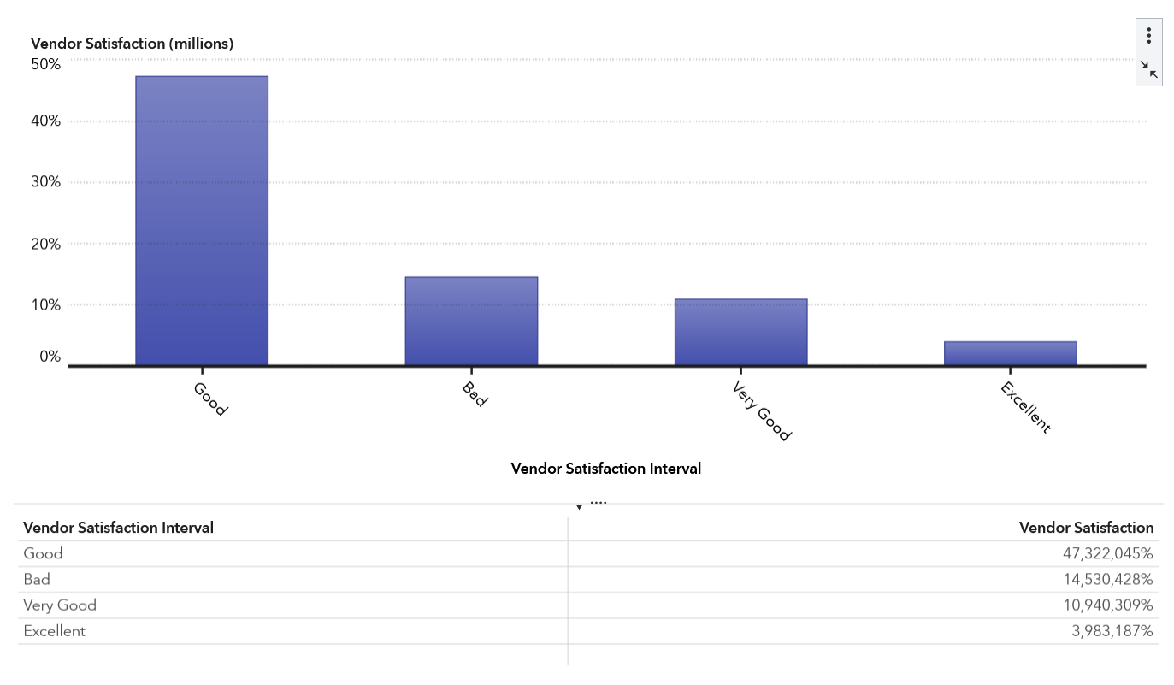

Figure 1: Vendor Satisfaction Interval by Vendor Satisfaction

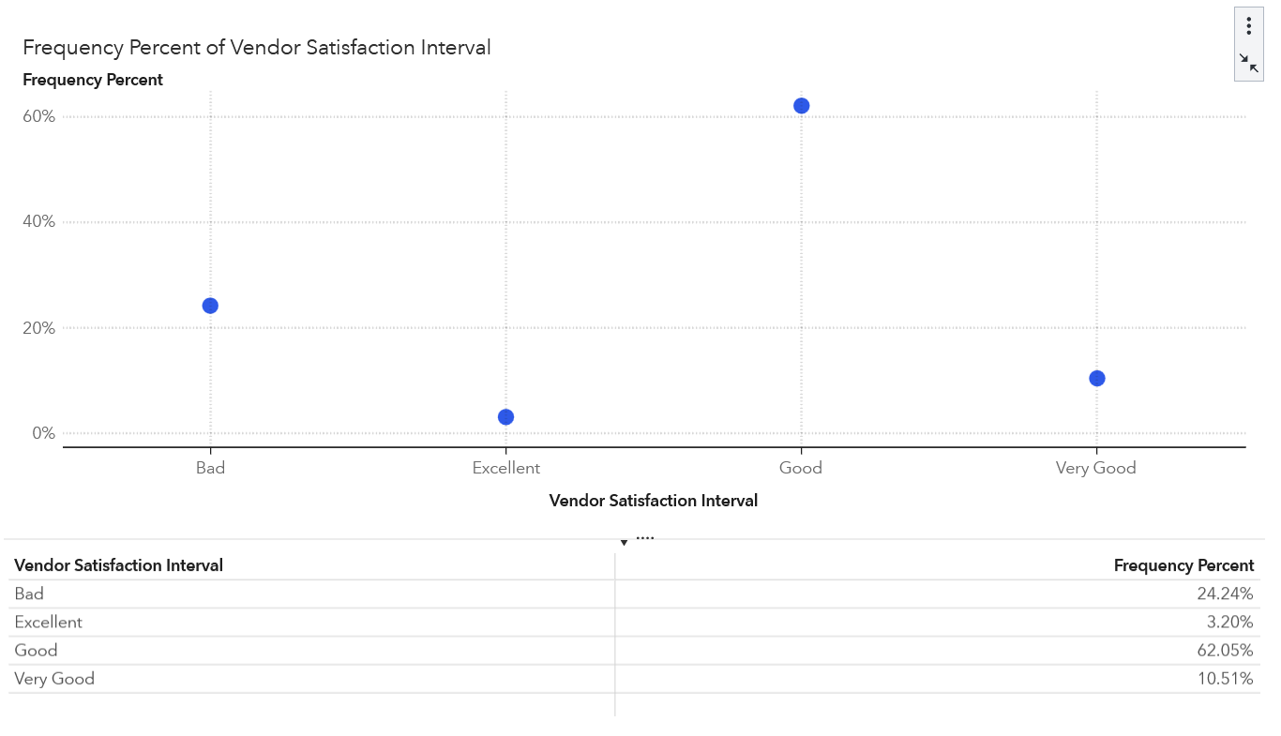

Figure 2: Vendor Satisfaction Interval by Frequency Percentage

**Data Exploration Tasks**

**DE1. Top 5 Countries by Gross Profit Margin**

Figure 3 provides a detailed look at the gross profit margins for the top five countries, excluding the United States. The color scheme used in the figure is derived from True Profit, enhancing the visual representation of the data. Notably, Great Britain stands out with the highest gross profit margin, reaching an impressive 54%. In contrast, Mexico (MX) records the lowest margin at 22%, signaling significant differences in profitability among these markets. Brazil (BR) secures the second position in gross profit margin, demonstrating a robust financial performance compared to the others in the top five.

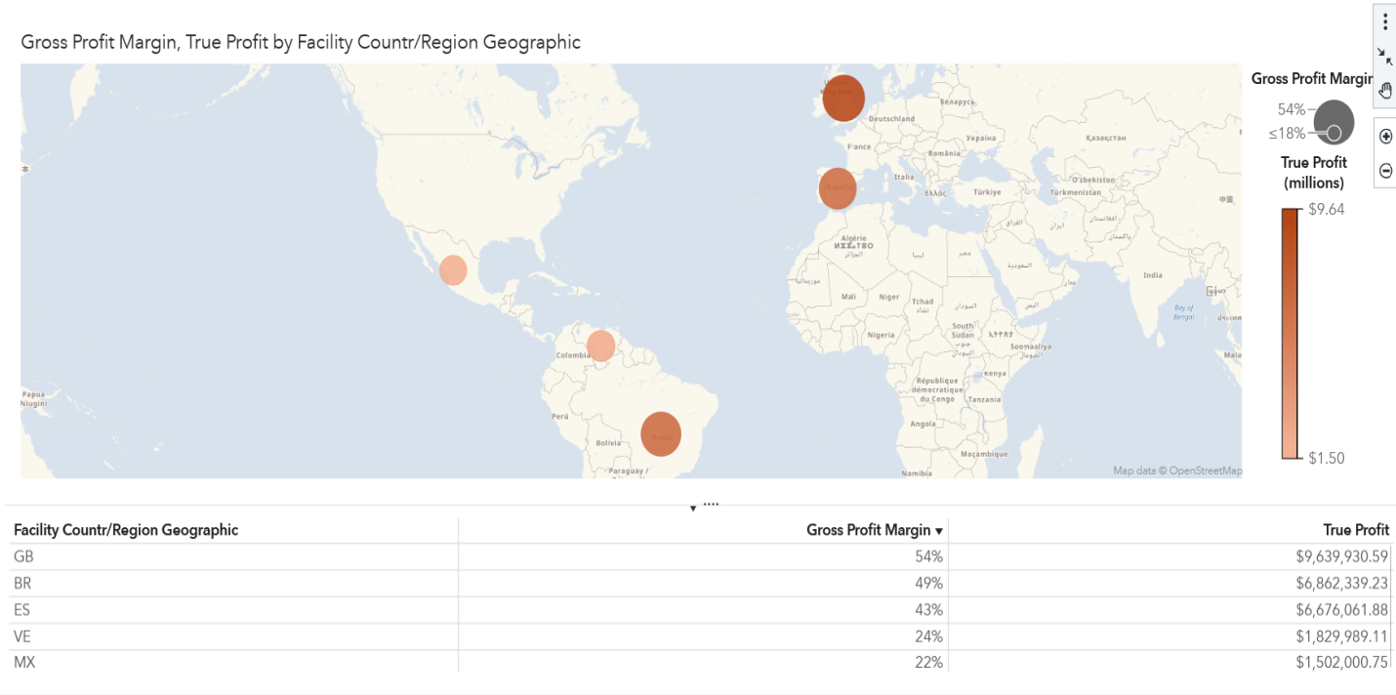

Figure 3: Top Five Countries by Gross Profit Margin

**DE2. Sales Rep Rating Above 70%**

Figure 4 presents a visual representation of the countries that have achieved a sales representative rating of over 70%. In this chart, we categorize the data by the geographic location of the facilities, with the size of each category reflecting the corresponding sales rep rating. Notably, the United States stands out as the leader in sales rep ratings, indicating strong customer satisfaction and effective sales performance. Conversely, Indonesia has the lowest percentage in this ranking, suggesting potential areas for improvement. Peru takes a commendable second place, showcasing a significant rating that enhances its standing. Overall, the countries demonstrating the highest sales representative ratings include the United States, Peru, Venezuela, and others, highlighting the regions where sales teams excel in their customer interactions and service quality.

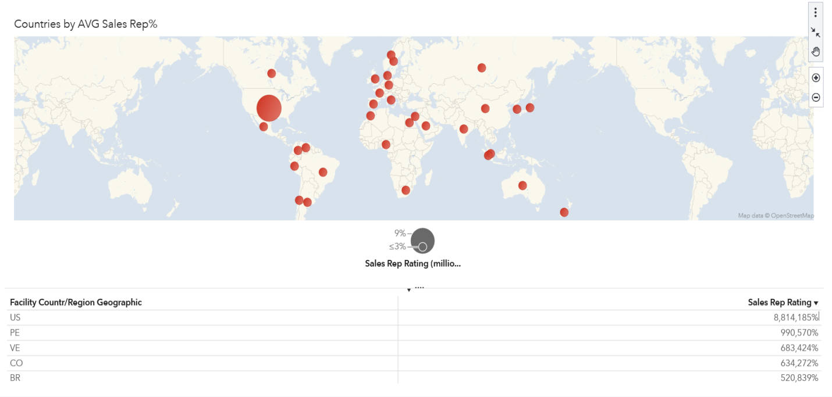

Figure 4: Top countries by AVG. sales rep rating

**DE3. Top Brand, Line, Make, and Style by True Profit**

Figure 5 illustrates a detailed tree map that categorizes various Product Brands. In this visualization, the brand serves as the category, while the size of each rectangle represents the Order Total and the color signifies the True Profit. Notably, the analysis reveals that the Toy brand stands out as the highest performer, boasting an impressive true profit of $194,857,497.57, paired with a substantial order total of $379,719,371.81.

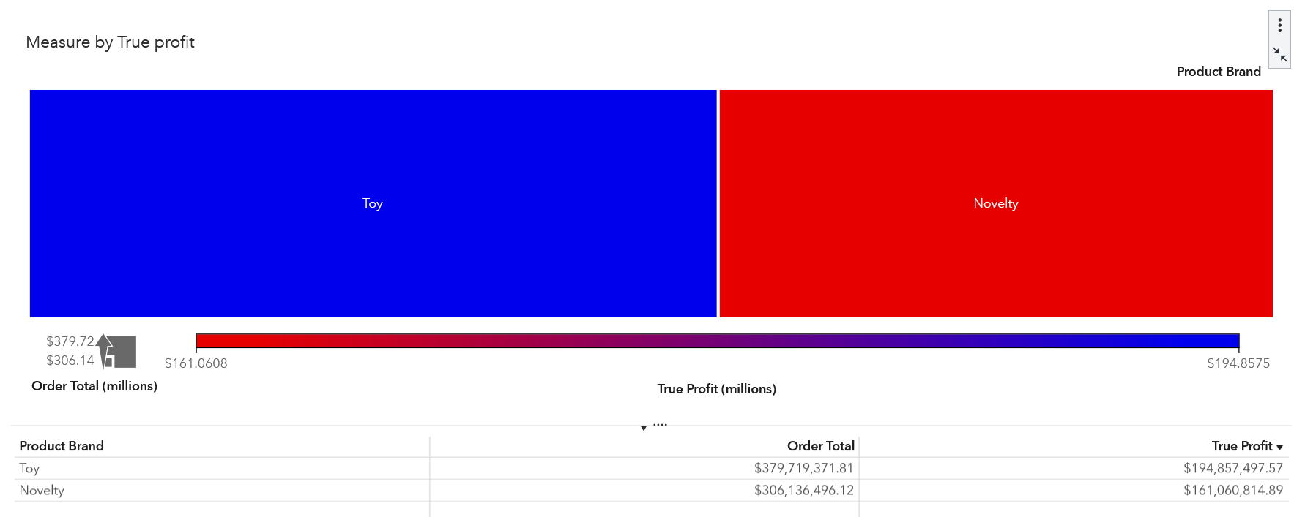

Figure 5: Top Brand

Moving on to Figure 6, we encounter another tree map that focuses specifically on Product Lines, evaluated by True Profit. This graphic highlights the Game Product Line as the frontrunner, achieving a remarkable true profit of $94,412,020.85. In contrast, the Thrift Product Line lags behind, with a significantly lower true profit of $3,480,105.21, illustrating a clear disparity among the different lines.

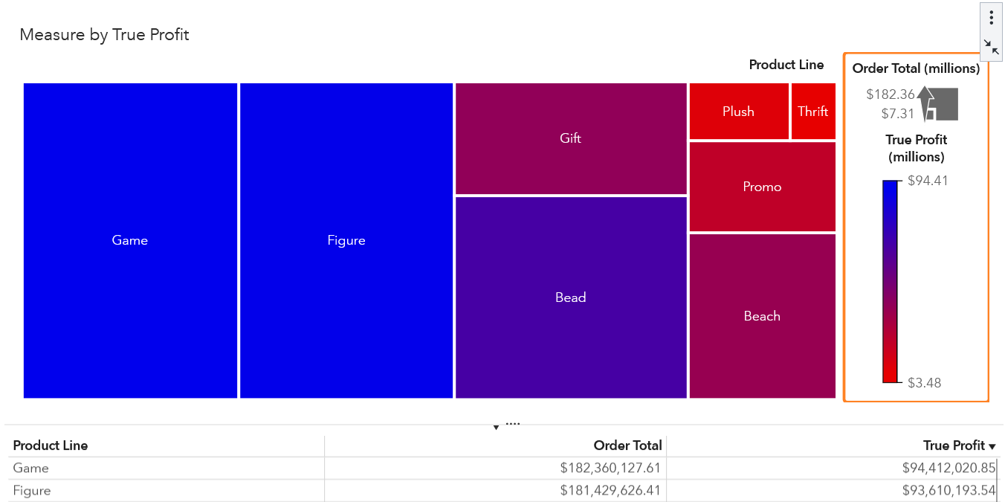

Figure 6: Top Product Line

Figure 7 shifts our attention to the Top Product Makes, again measured through the lens of True Profit. This visualization shows that the top-ranking Product Make is a Board Game (3), indicative of its popularity and profitability. Conversely, Clips are positioned at the bottom, reflecting a lesser market impact.

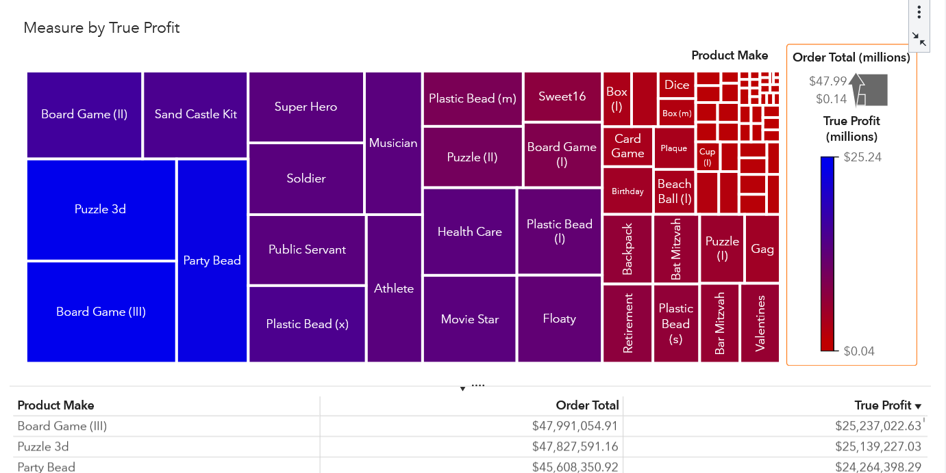

Figure 7:Top Product Make

In Figure 8, the visualization of Product Style clearly illustrates the performance of different categories. The female Product Style stands out at the top, achieving a remarkable True Profit of $6,648,672.44. This impressive figure highlights the strong market appeal and consumer preference for female-oriented products. Following closely in second place is the male Product Style, which has garnered a True Profit of $6,627,145.44. This indicates a healthy demand and a competitive position but still trails slightly behind the female segment. In stark contrast, the Tennis category occupies the lowest position in this ranking, underscoring its lesser performance in terms of profitability compared to the other styles.

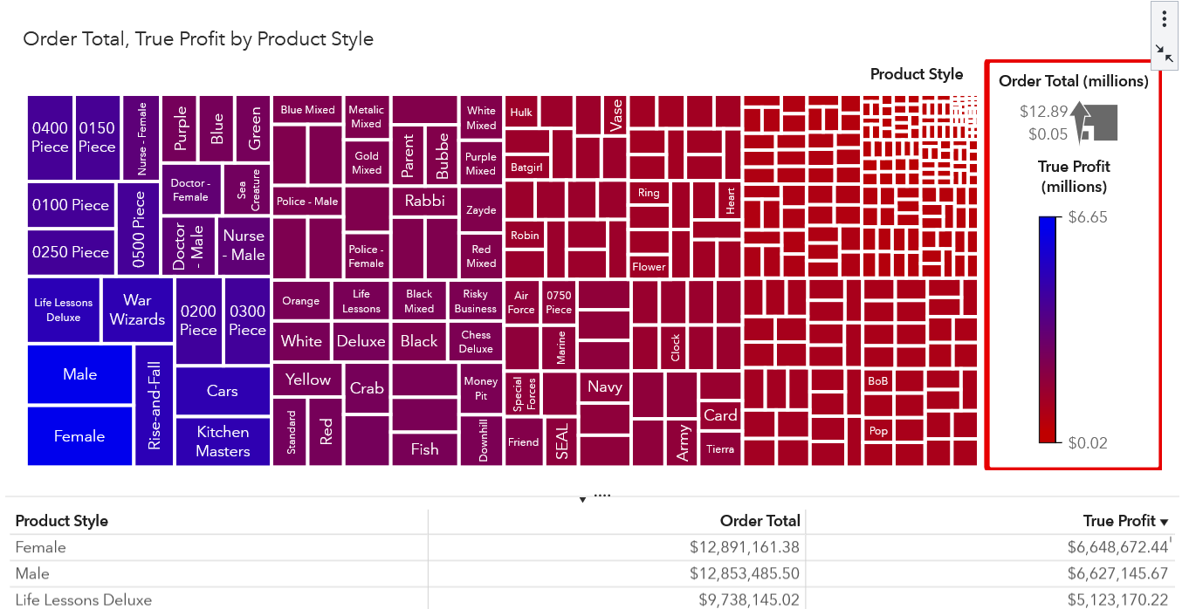

Figure 8: Top Product Style

**DE4. Promo Line Outliers by True Profit**

In Figure 9, we present a comprehensive visualization that integrates both a box plot and a bar chart to provide insights into product performance. The box plot effectively highlights the highest outlier in our dataset, specifically for the product "Make Board Game (3)," which is included in the product line categorized as games. This outlier represents a significant value that stands apart from the other data points.

Accompanying this visual, the bar chart utilizes product hierarchy as its category to clearly depict the relationship between various products and their respective true profit figures. This chart distinctly illustrates the performance of the promotional line associated with games, emphasizing "Make Board Game (3)" as the leading product in terms of true profit. Together, these visualizations enhance our understanding of product profitability and the effectiveness of promotional strategies.

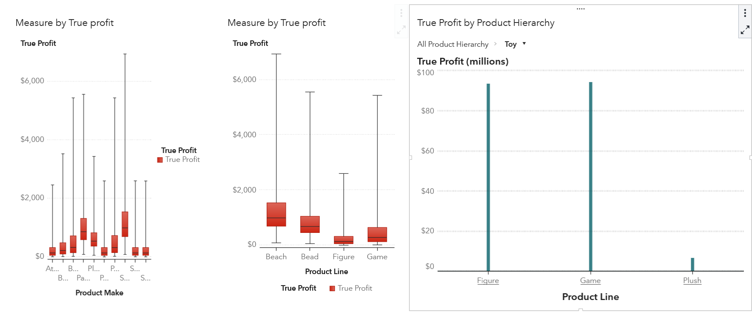

Figure 9: Promo Line and Top Product Make

**DE5. Sales Comparison between Toy and Novelty Brands**

In Figure 10, we present a detailed sales comparison among various brands using Line Chart Graph. For this analysis, we utilize Order Total as the primary metric for evaluating sales performance, with Transaction Date serving as the timeline for our observations and Product Brand as the categorization criterion. The visual data indicate that, overall, Toy products achieved the highest sales figures throughout the examined period. However, in October 2013, there was a notable shift as sales of Novelty products outperformed those of Toy products, highlighting the changing dynamics of consumer preferences.

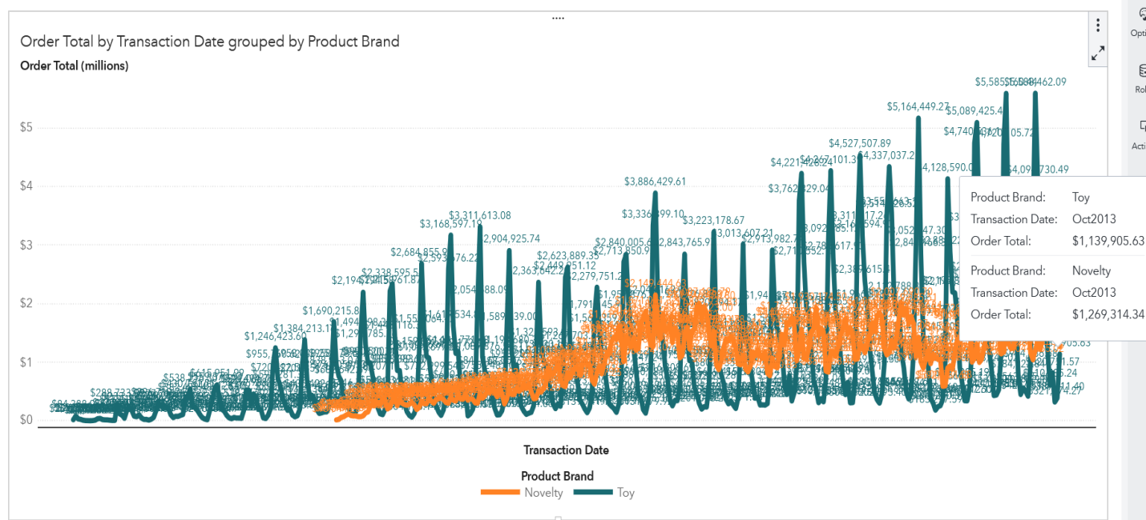

Figure 10: Sales comparison between two brands by transaction date.

Through our comprehensive exploration tasks, we have successfully identified the leading countries in terms of Gross Profit Margin, excluding the United States. The top five countries are Great Britain (GB), Brazil (BR), Spain (ES), Venezuela (VE), and Mexico (MX). While the United States stands out as the highest-ranked country based on sales representative ratings, it is noteworthy that Indonesia occupies the last position on this scale.

Delving into our product analysis, we employed Order Total to represent size and True Profit to convey color significance. This analysis reveals that the standout brand is Toy, with the Game product line taking the top spot. Among the various products, the Board Game (3) emerges as the most frequently manufactured item, and the predominant style within this category is Female.

When we examine the visualization of outliers, the Board Game (3) consistently ranks as the top product, categorized under the Game product line. This emphasizes that both the Board Game (3) and its associated product line significantly contribute to achieving remarkable True Profit margins.

Furthermore, a detailed line chart visualization illustrates that the Toy brand dominates sales figures overall. However, it is interesting to note that only in October 2013 did the Novelty category experience a surge, capturing high sales during that specific month. This distinction highlights the fluctuating trends in consumer preferences and sales performance across different product categories and timeframes.

**Data Analysis Tasks**

**DA1. Order Total Forecasting**

In Part One of the analysis, we created a line chart with Transaction Date as the category and both Order Total and Order Product Cost as measures. The chart demonstrates that both lines move in parallel; when the product cost is high, the Order Total also increases. From 2010 to 2013, it is evident that the product cost positively influenced the Order Total.

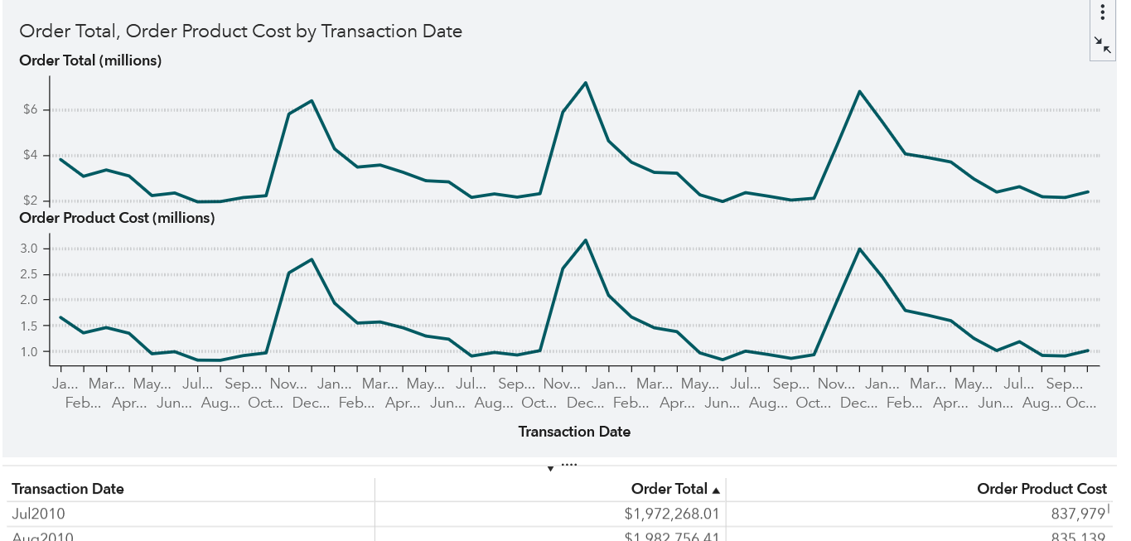

Figure 11: Order total and order product cost by date

The forecast graph indicates that the Predicted Order Total closely matches the Actual Order Total, with the predicted sales sometimes showing upward trends. The forecasted sales are highly correlated with actual sales, showing a 95% forecast confidence level.

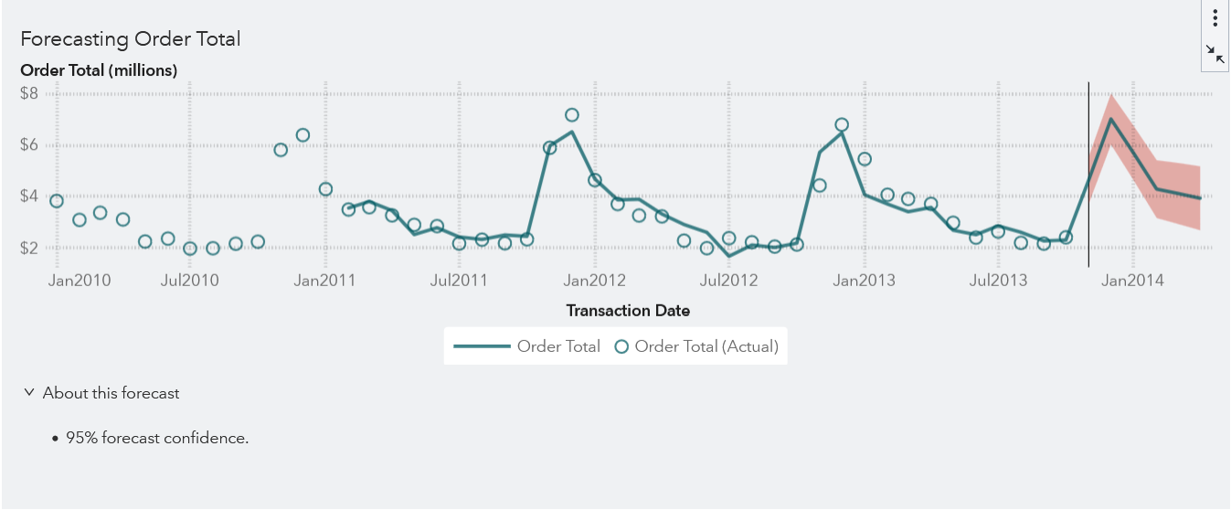

Figure 12: Forecasting Order Total

Additionally, we developed a multiple linear regression model where Order Total serves as the dependent variable, while Order Marketing Cost, Sales Rep Rating, and Vendor Satisfaction are treated as independent variables. The analysis reveals that Order Marketing Cost positively impacts Total Sales. While Sales Rep Rating and Vendor Satisfaction appear less influential, it's worth noting that Order Marketing Cost exhibits a strong correlation with Total Sales. Therefore, an increase in marketing cost by 20% could enhance total sales.

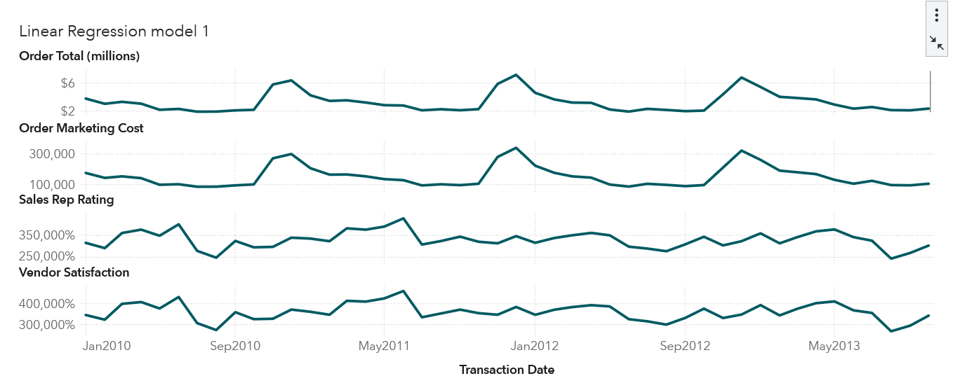

Figure 13: Linear Regression Model 1

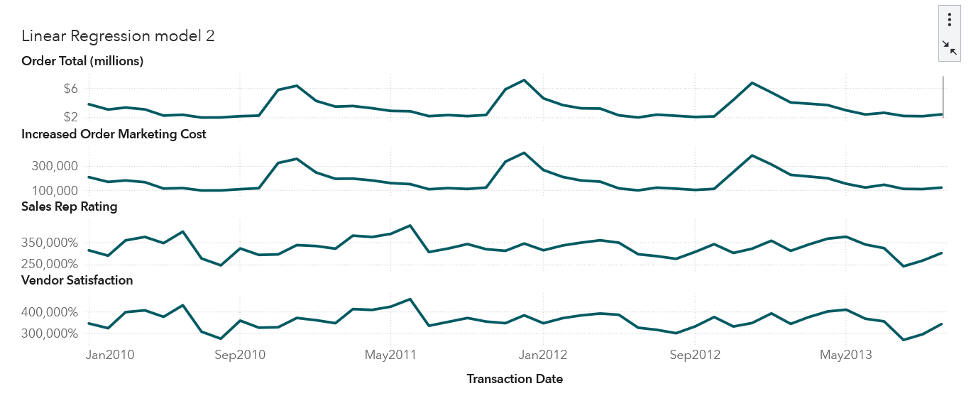

Figure 14: Linear Regression Model 2

Figures 15 illustrate a strong correlation between Order Total and the increased Order Marketing Cost. We also observe a high correlation between Sales Rep Rating and Vendor Satisfaction; however, both factors show a weak correlation with Order Total.

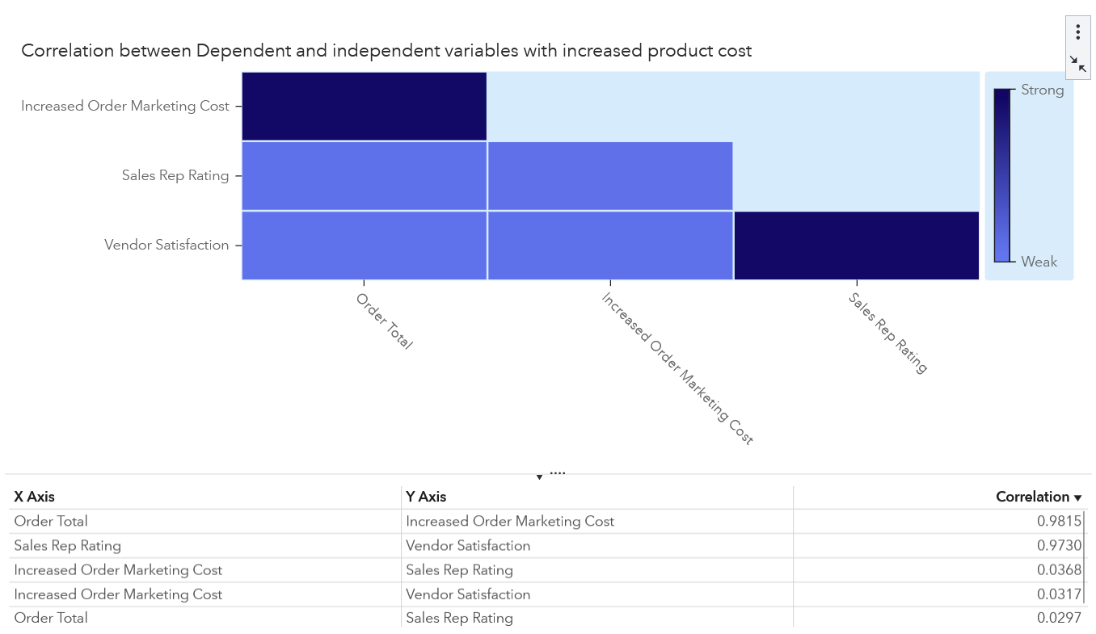

Figure 15: Correlation between Dependent and Independent variables.

In summary, the analysis concludes that the total sales predictions align closely with actual sales figures. If Order Marketing expenditures increase, it is likely that total sales will also rise. Furthermore, enhancing Sales Rep Ratings or Vendor Satisfaction could positively affect sales performance, even without changes to marketing strategies.

**DA2. Correlation Matrix for Vendor Satisfaction**

In the second phase of our analysis, we developed a correlation matrix to explore the relationships among various measures and their impact on vendor satisfaction. The findings reveal that the Sales Rep Rating is strongly positively correlated with vendor satisfaction, indicating that favorable perceptions of sales representatives are linked to higher levels of satisfaction among vendors. Conversely, Order Sales Cost shows a strong negative correlation with vendor satisfaction, suggesting that higher costs associated with orders tend to diminish vendor contentment. Additionally, the correlation related to vendor distance demonstrates a weak connection, though it stands out as the highest among other weak correlations.

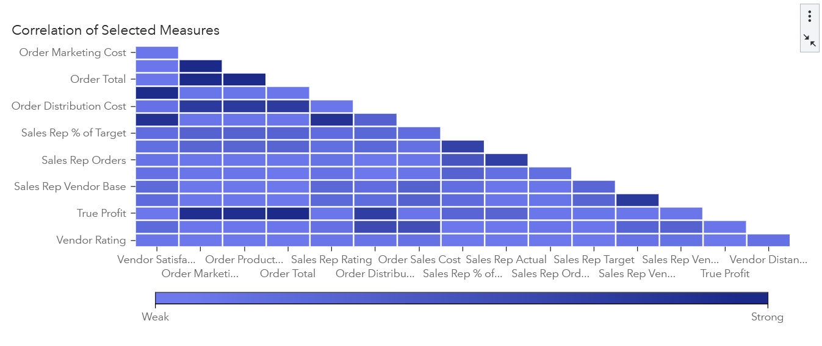

Figure 16: Correlation Matrix

To visually illustrate these relationships, Figure 16 features a line chart that tracks trends across the three measures. Notably, both the Sales Rep Rating and Order Sales Cost display similar upward trends that align closely with vendor satisfaction. This suggests that as sales representative ratings improve and order costs are managed, vendor satisfaction also tends to increase. Therefore, based on the insights gained from this analysis, it is imperative that we focus on enhancing the Sales Rep Rating while simultaneously working to lower Order Sales Costs in order to boost vendor satisfaction significantly.

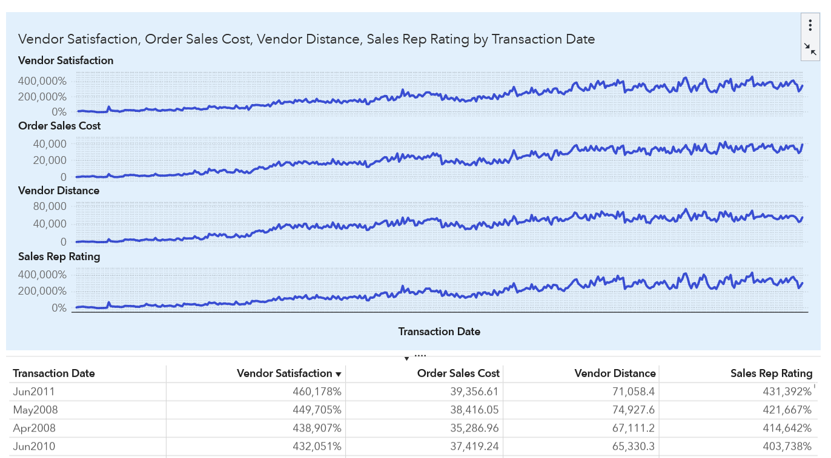

Figure 17: Analysis between three measures which are strongly correlated

**DA3. Decision Tree Analysis for Scaled Vendor Satisfaction**

Through decision tree analysis, we can determine when scaled vendor satisfaction is low by examining several factors, including marketing penetration, order sales cost, sales rep rating, vendor distance, vendor rating, vendor loyalty program, and facility contents.

Specifically, if the sales rep rating falls below 0.28 or exceeds 0.92 in node one, the vendor satisfaction interval is considered poor, with a percentage of 58.53. Additionally, if the order sales cost is greater than 6.49 and the sales rep rating is between 0.28 and 0.44 in node 10, the vendor satisfaction interval is also categorized as bad.

In node 27, when the Sales Rep Rating is greater than or equal to 0.92 and the Vendor Distance is greater than or equal to 10, the vendor satisfaction interval is excellent, with a percentage of 91.22.

From this analysis, it is evident that the most significant factor influencing vendor satisfaction is the sales rep rating. Conversely, order sales cost positively affects the vendor satisfaction interval. Understanding these dynamics can help organizations make informed decisions to enhance vendor satisfaction and foster stronger partnerships.

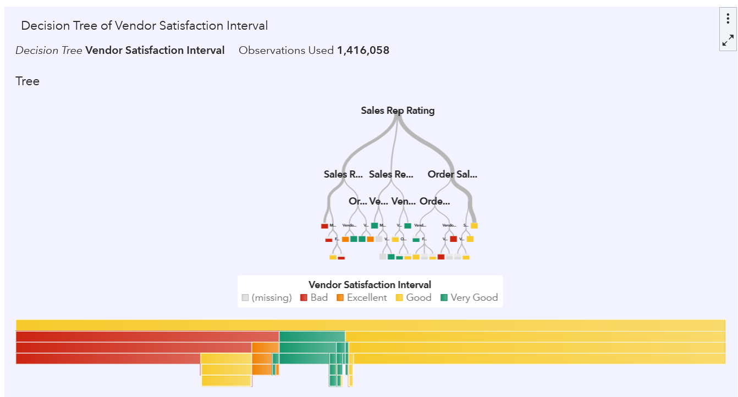

Figure 18: Decision Tree Analysis

**DA4. Product Association with Profit-Cost Analysis**

A comprehensive analysis was conducted using a Network Diagram to examine the associations between various products, focusing on their profit margins and associated costs. In this analysis, we incorporated a structured product hierarchy as different levels, represented true profit by varying the size of nodes, and utilized color coding to denote the order total associated with each product. To gain specific insights, we narrowed our focus to December’s sales data by filtering the diagram based on transaction dates.

The findings from the network diagram reveal that the Figure product line achieved the highest true profit and gross sales in December. This category includes various items such as products for athletes, soldiers, healthcare professionals, and public servants, indicating a diverse range of customers. The close association of these products suggests they were frequently sold together, highlighting potential cross-selling opportunities.

Moreover, the Game product line emerged as the second highest in terms of sales for December. Within this line, Board Games (1), Board Games (2), and Card Games were commonly purchased together, indicating a strong market for tabletop entertainment during this period. Additionally, there is a notable connection between the Game category and the Puzzle 3D product make, which is further linked to the Promo product line, suggesting promotional strategies might have effectively driven these sales.

In summary, the analysis indicates that in December, multiple product types were often sold in conjunction with their respective makes, with significant sales performance observed for the Game, Figure, and Promo product lines. This information can be valuable for future marketing and inventory strategies to maximize sales in similar periods.

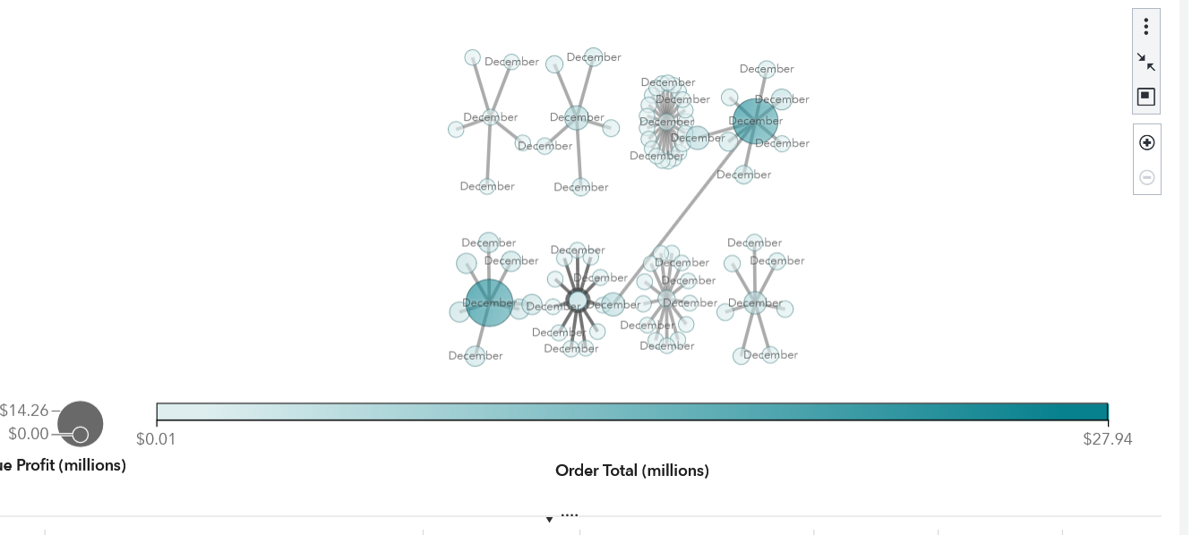

Figure 20: Network Diagram**.**

**DA5. Vendor Numeric Distribution by Facility**

A comprehensive numerical distribution analysis of vendors was undertaken to evaluate how vendors are distributed across different facilities. This analysis revealed clear patterns in the numeric distribution of vendors, highlighting significant variations among the facilities. Specifically, it was observed that certain facilities host a higher concentration of particular vendors. This finding suggests that logistical factors, especially the proximity of these vendors to the facilities, play an important role in the selection and engagement of vendors. The analysis emphasizes the importance of geographic location in vendor relationships and provides valuable insights for strategic decision-making regarding vendor management and facility operations.

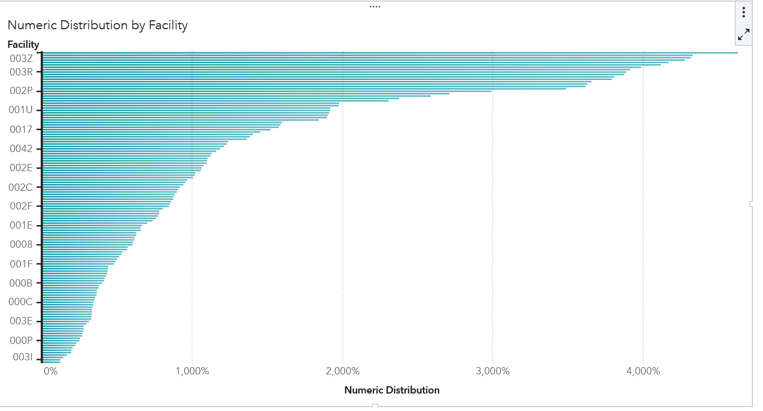

Figure 21: Numeric Distribution of Facility

Based on the overall analysis, we can conclude that the total sales predictions closely align with actual sales figures. If Order Marketing expenditures increase, it is likely that total sales will also rise. Additionally, improving Sales Rep Ratings or Vendor Satisfaction could positively impact sales performance, even in the absence of changes to marketing strategies.

Notably, both Sales Rep Ratings and Order Sales Costs display similar upward trends that align closely with vendor satisfaction. This suggests that as sales representative ratings improve and order costs are managed effectively, vendor satisfaction tends to increase as well. Therefore, it’s crucial that we focus on enhancing Sales Rep Ratings while simultaneously working to reduce Order Sales Costs in order to significantly boost vendor satisfaction.

The Decision Tree analysis indicates that the most significant factor influencing vendor satisfaction is the sales rep rating. In contrast, order sales cost has a positive effect on the vendor satisfaction interval. Understanding these dynamics can help organizations make informed decisions to enhance vendor satisfaction and foster stronger partnerships.

The Network Diagram analysis shows that in December, multiple product types were frequently sold together with their respective brands, resulting in significant sales performance for the Game, Figure, and Promo product lines. This information can be valuable for future marketing and inventory strategies aimed at maximizing sales during similar periods.

**Conclusion and Recommendations**

Based on the analysis conducted, the following key insights and recommendations are presented:

1. Increase Marketing Investment: It is projected that a 20% increase in marketing investment could lead to a 15% increase in sales. This finding underscores the potential of strategic marketing investments to foster growth, particularly within the Toy brand sector.

2. Enhance Vendor Relationships: The satisfaction of vendors is a critical factor influencing sales performance. A dedicated effort to strengthen vendor relationships, especially in regions with lower performance metrics, may yield improved overall business results.

3. Prioritize Product Promotions: The implementation of promotional strategies for high-margin products, particularly during the month of December, is essential for maximizing profitability. A thorough understanding of product associations can aid in the effective tailoring of these promotional efforts.

4. Monitor Global Trends: Continuous monitoring of sales trends across various countries and regions is imperative, as geographic factors can significantly impact sales outcomes.

By capitalizing on these insights, Insight Toy Company can adopt data-driven decision-making to enhance sales performance, profitability, and overarching business strategies. Further in-depth analysis of emerging markets and product lines will reveal additional avenues for growth and optimization. This report provides a comprehensive overview of the current business landscape and employs data-driven methodologies to identify critical areas for improvement. The integration of forecasting techniques and decision trees establishes a robust foundation for future strategic initiatives.